ABOUT THE GREAT OCEAN ROAD WOMENS SURF FEST

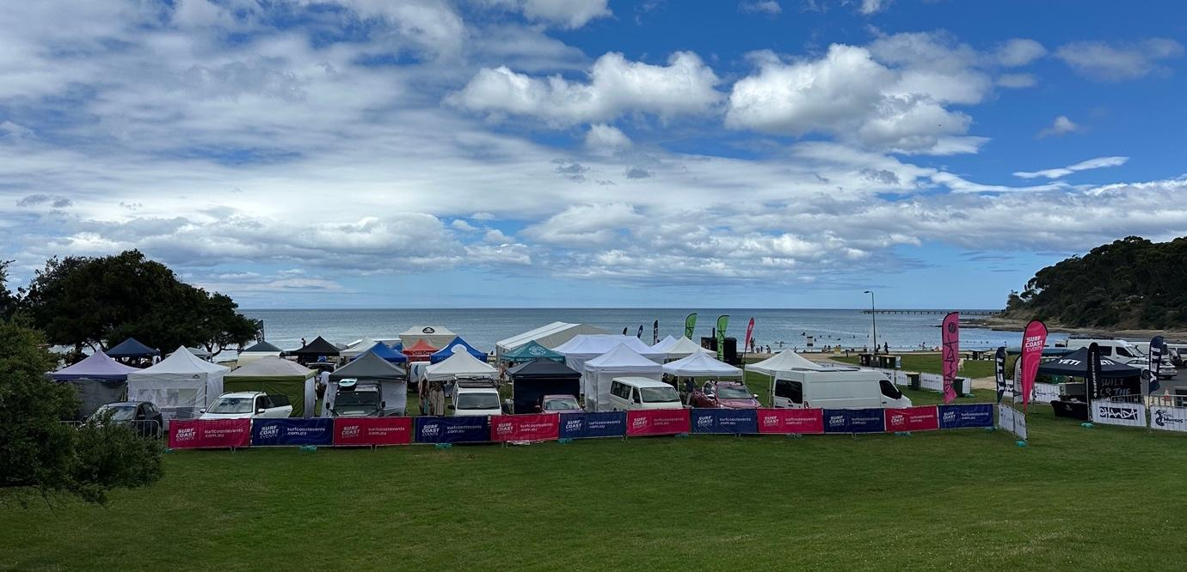

A Social Script

We are going to the Great Ocean Road Women’s Surfing Fest Event.

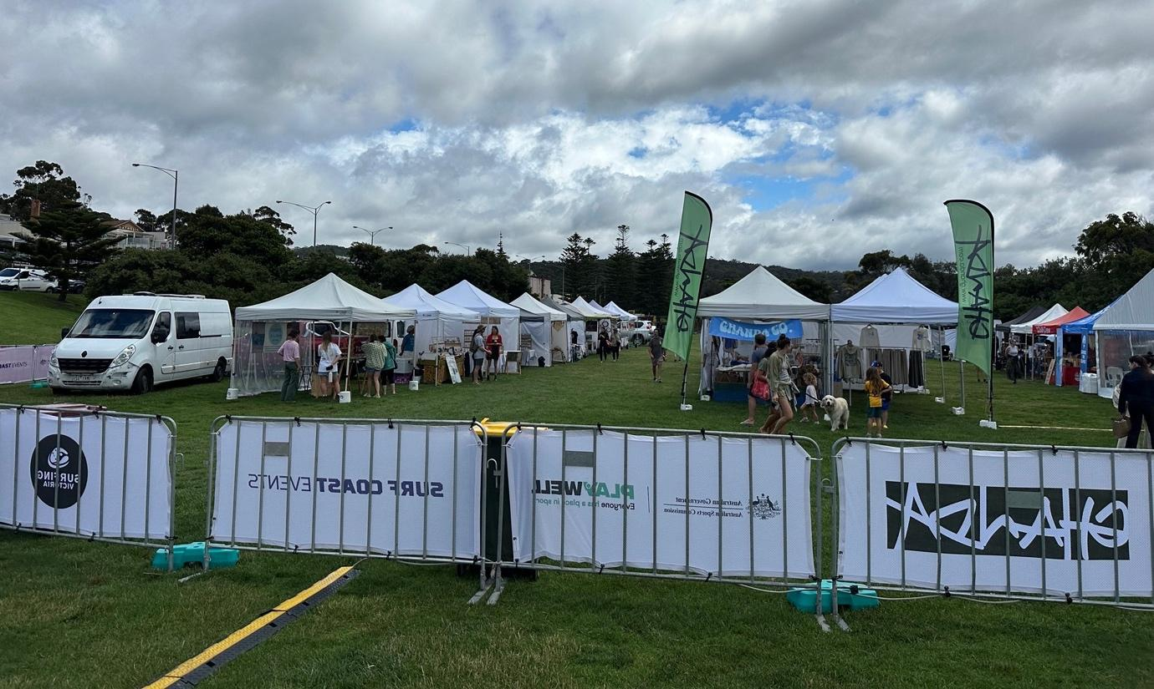
It will run for 2 days, Saturday 7th and Sunday 8th November, from around 8am - 3pm each day, depending on the surf conditions.

It is on the Lorne Foreshore, Mount Joy Parade, Lorne.

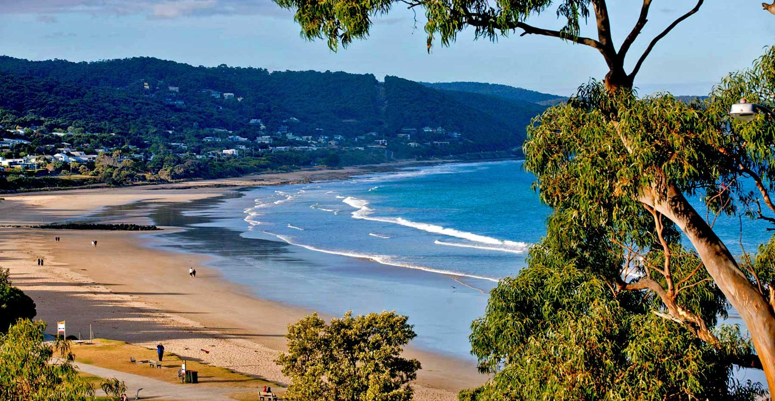

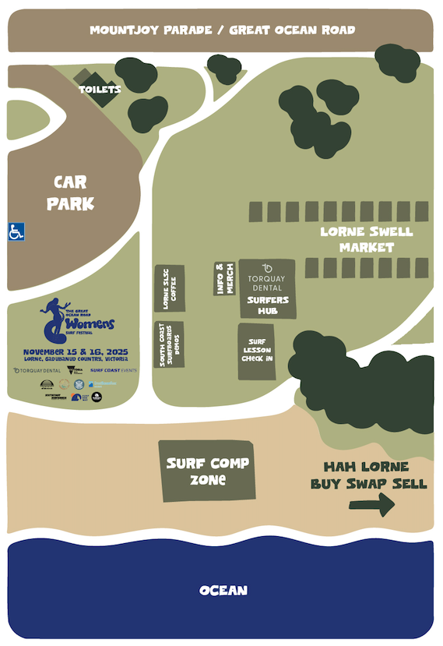
This map shows where everything will be.

There is disabled parking available.

Surfing competition will start at 8am. A surfing heat is when people compete against each other.
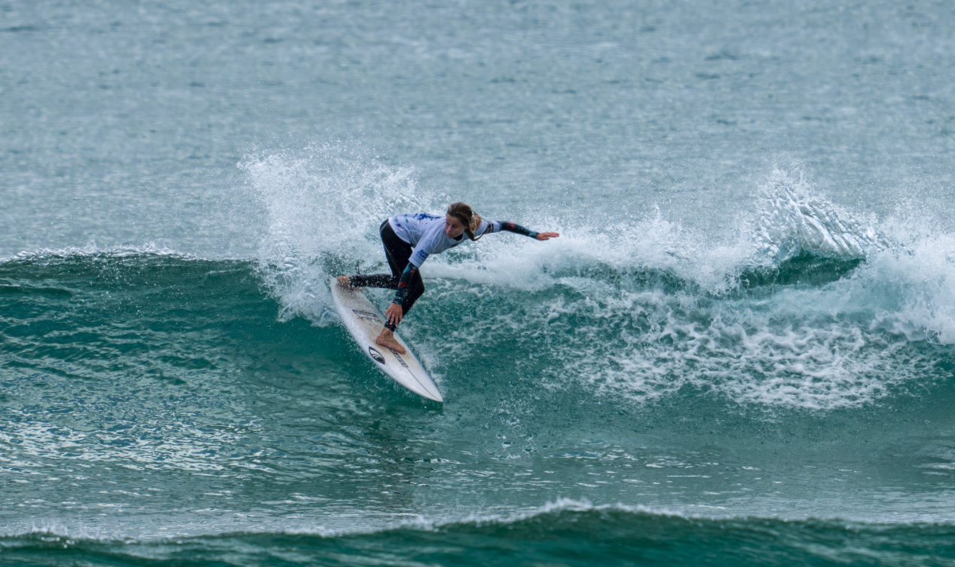

While the surfers are competing against each other, there may be some cheering from the people watching. There are also big speakers playing music and voices giving commentary. This can get noisy at times.

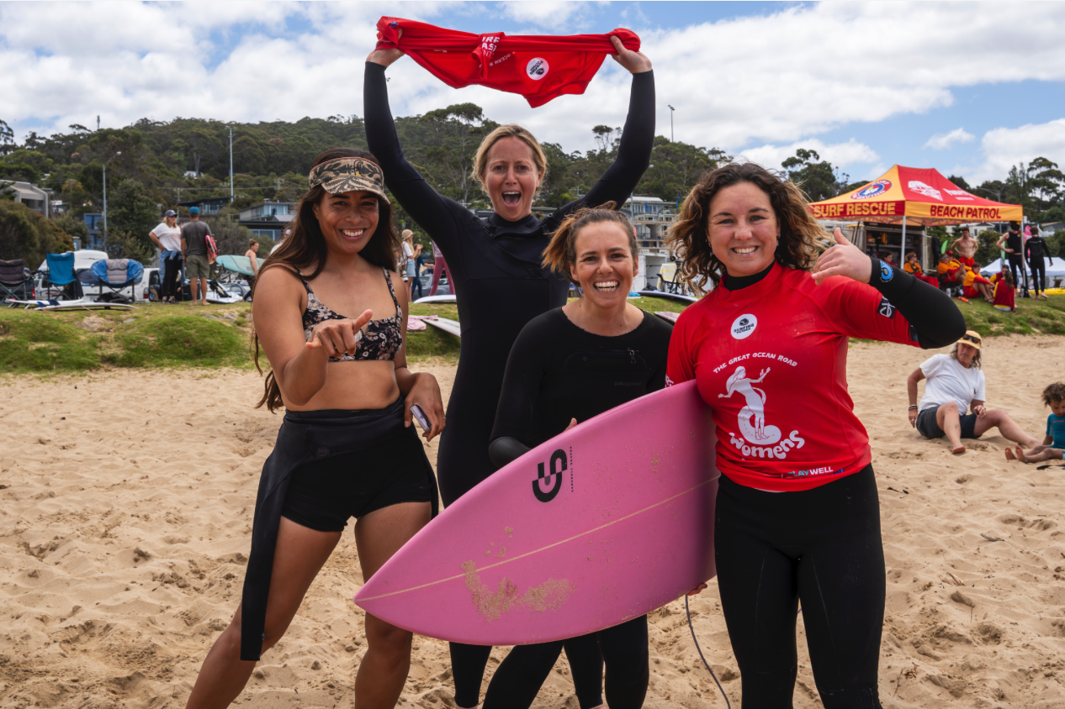
There will also be a siren at the start and the end of each heat so the surfers know when to start surfing and when to stop.
The siren will make a sound at the judges tent.

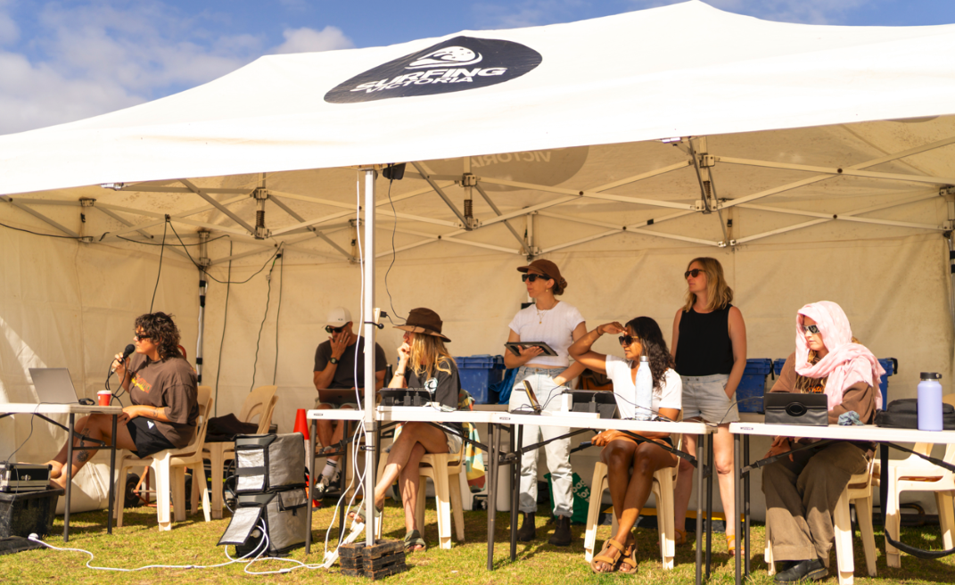

There will also be a market at the festival with some buskers playing music throughout the weekend.


If I need a break from the noise and the crowd, there is a quieter space on the sand where I can go. It is away from the crowd but I can still watch the surfing competition that’s happening in the ocean.

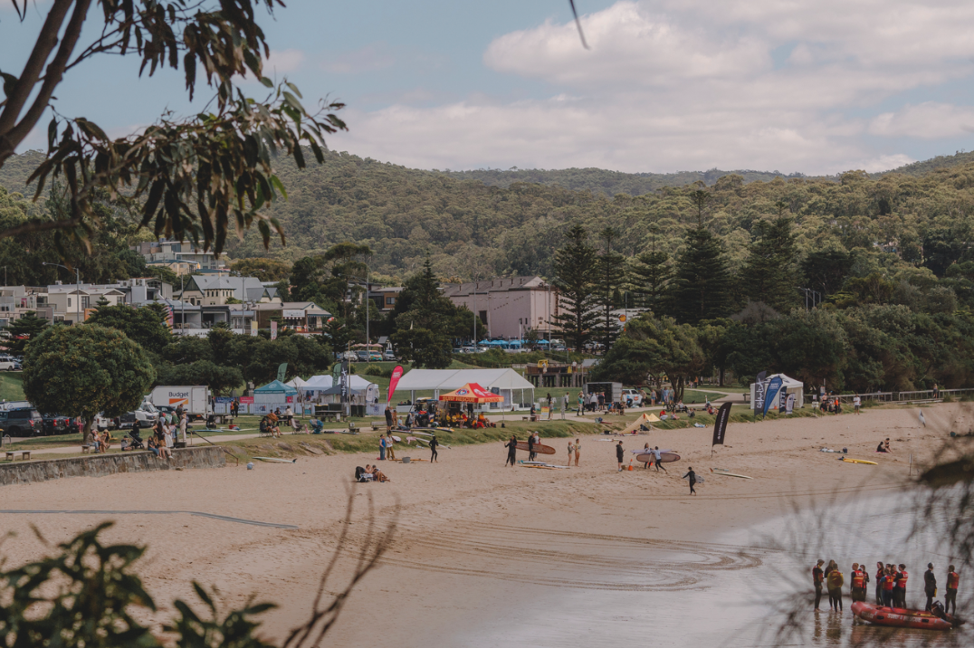
If it gets too loud, I can also use my own ear defenders or noise cancelling headphones.



I can leave and come back to the event at any time during the day if I need.
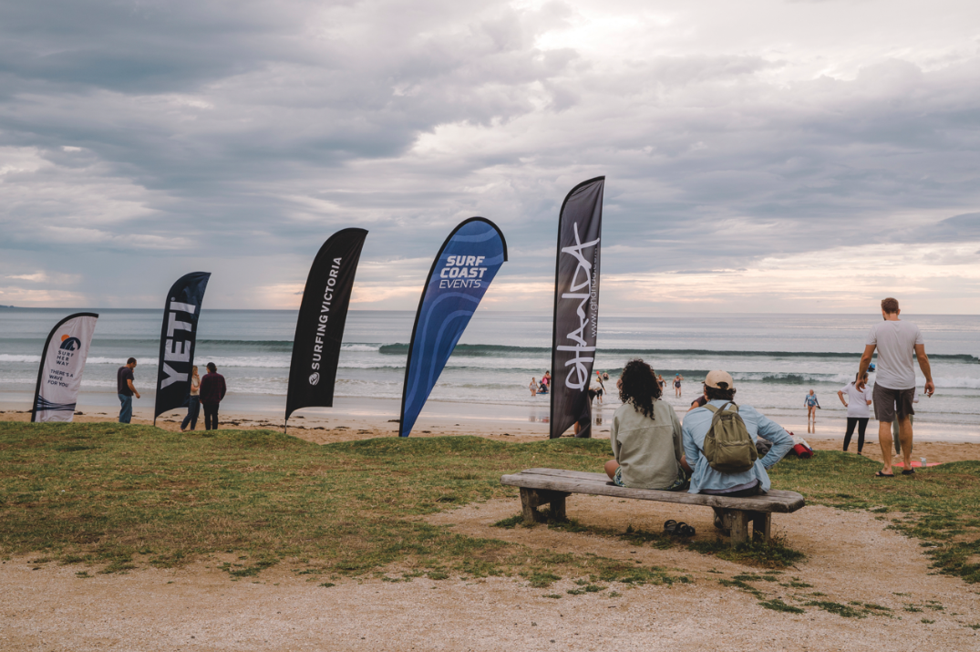

If I get hungry and I have money with me, there are food stalls where I can buy some food to eat.

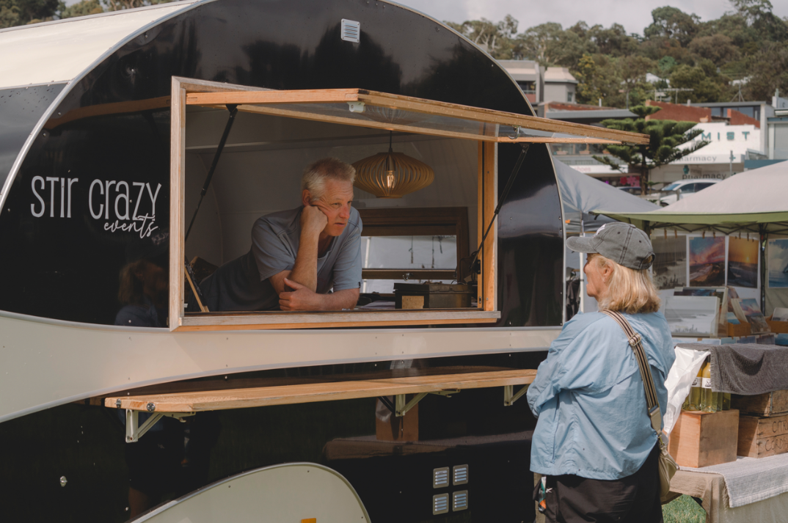

If I need help, there will be staff members at the INFORMATION & FIRST AID tent ready to help me.

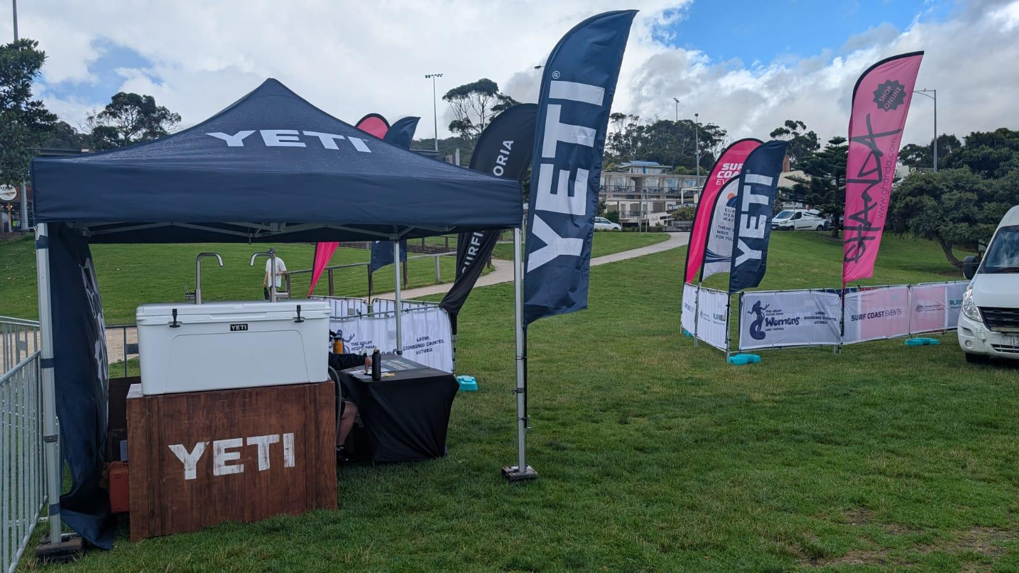

At the end of the event, it will be time to leave and go home.
Going to the Great Ocean Road Women’s Surfing Fest will be super awesome!



