ABOUT THE RIP CURL PRO PRESENTED BY BONSOY

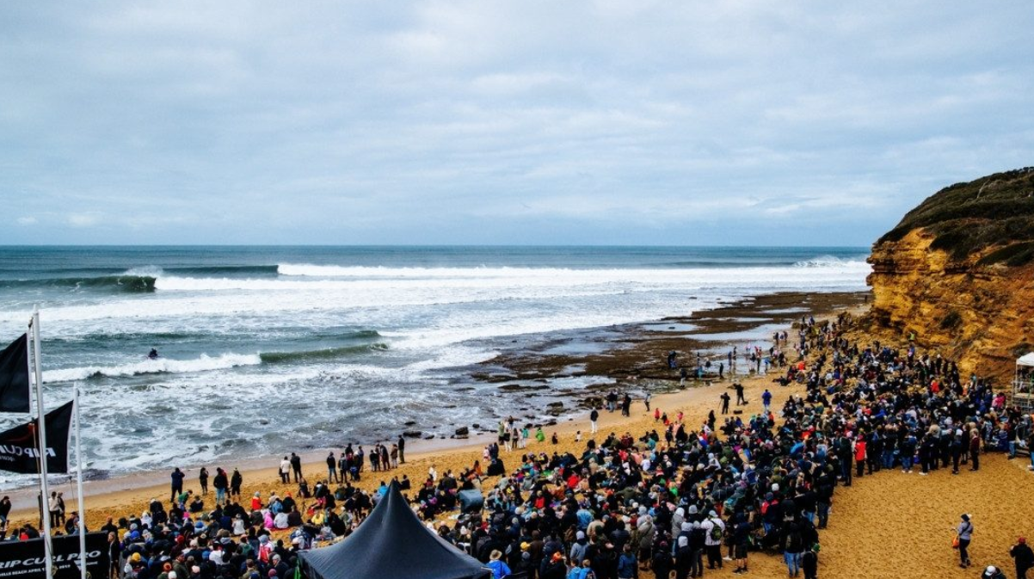

A Social Script

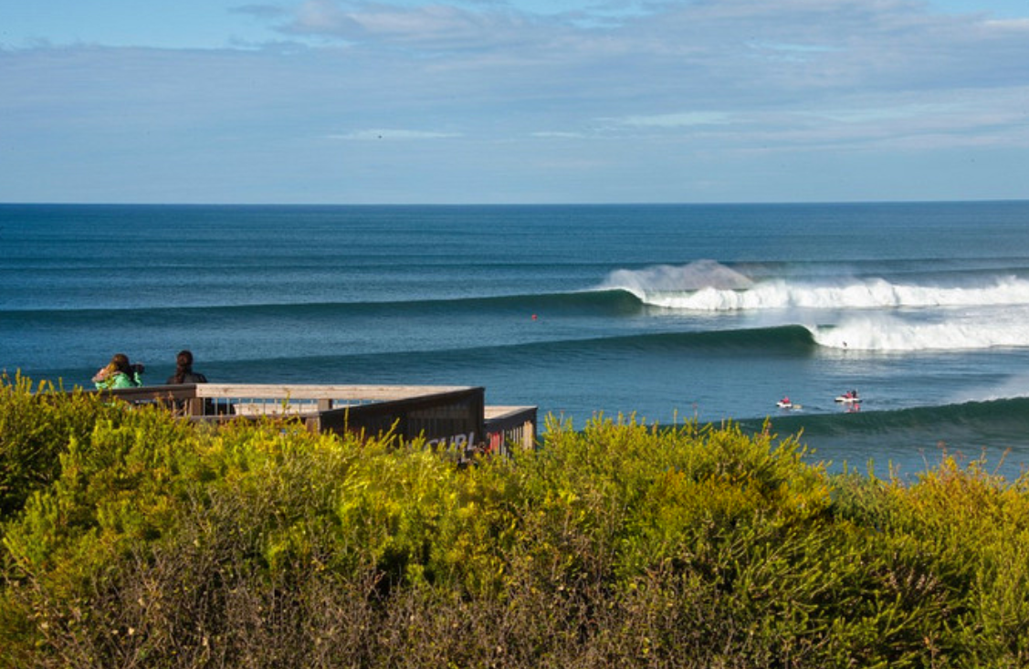
We are going to the Rip Curl Pro World Surfing Event.

It will run for 10 days, April 1 - April 11, from around 7am - 5pm each day, depending on the surf conditions.
It is at Bells Beach Surfing Recreation Reserve, Jarosite Road, Bells Beach.

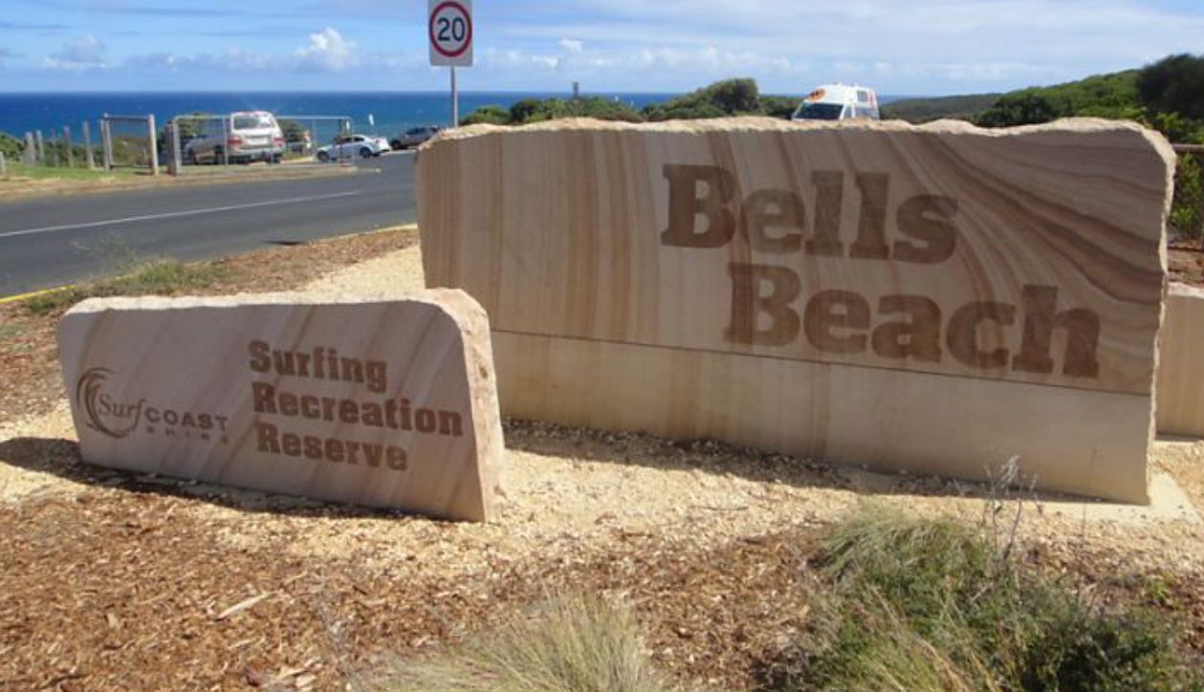

This map shows where everything will be.
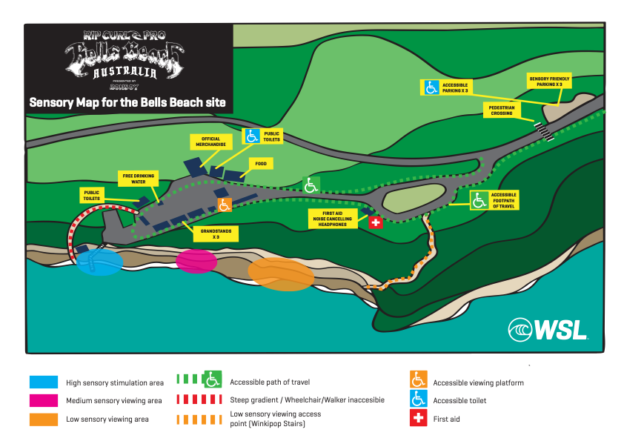

There is parking including disabled parking and sensory friendly parking for people with sensory sensitivity. If you have any questions on parking you can contact events@surfcoast.vic.gov.au

Surfing starts first thing in the morning if the surfing conditions (waves) are suitable.


If there are no waves, the surfing could be called off, or put on hold until the surfing conditions improve.
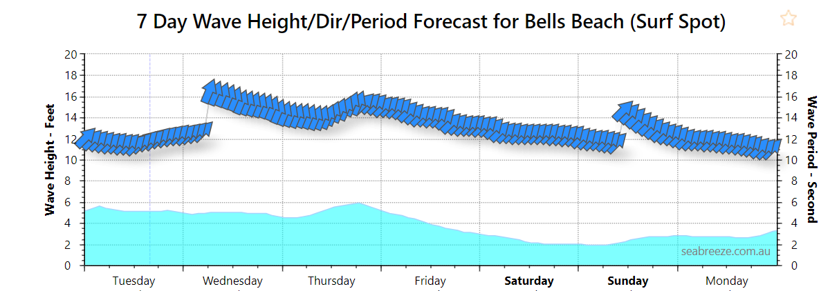
It might be worthwhile checking the surf and weather forecast before heading to Bells Beach. Good conditions are usually big swells and North-West winds.
I can find out if the event is going ahead by checking out www.worldsurfleague.com where I can also watch the action online.
There will be many surfing heats over the 10 days of competition.

A surfing heat is when people from around the world compete to see who is the best surfer in the world! 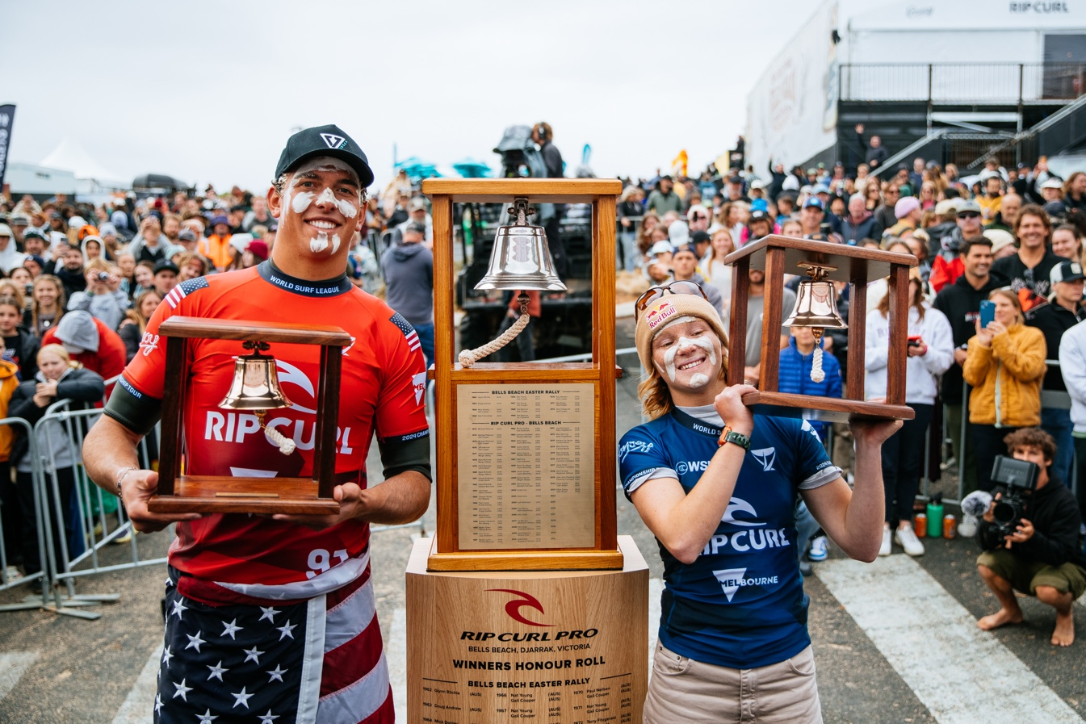
While the surfers are competing against each other, the crowd will be excited and cheering. There are also big speakers playing music and voices giving commentary. This can get noisy at times. 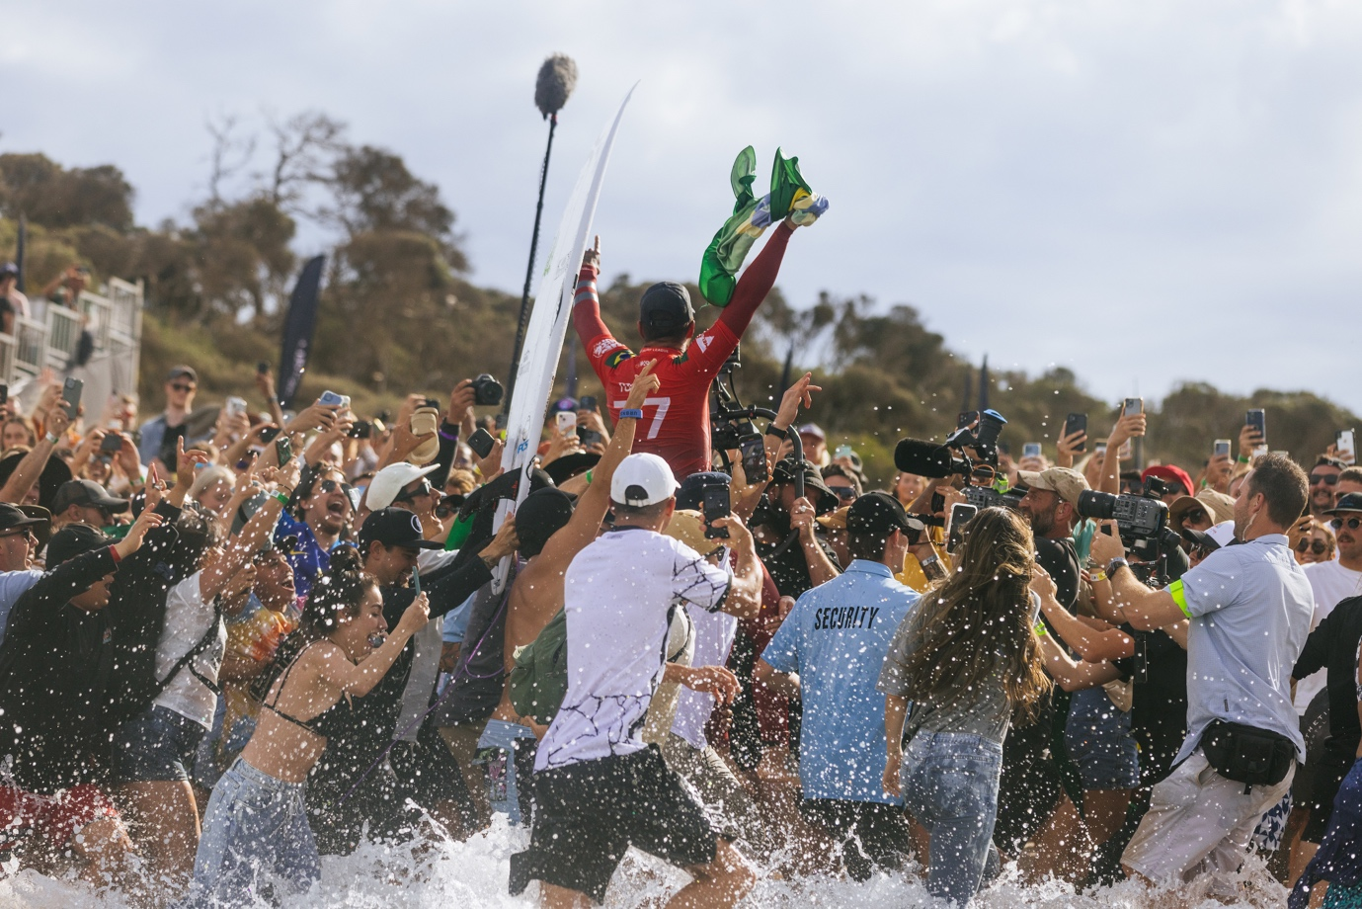

There will be lots of people there to watch the surfing.

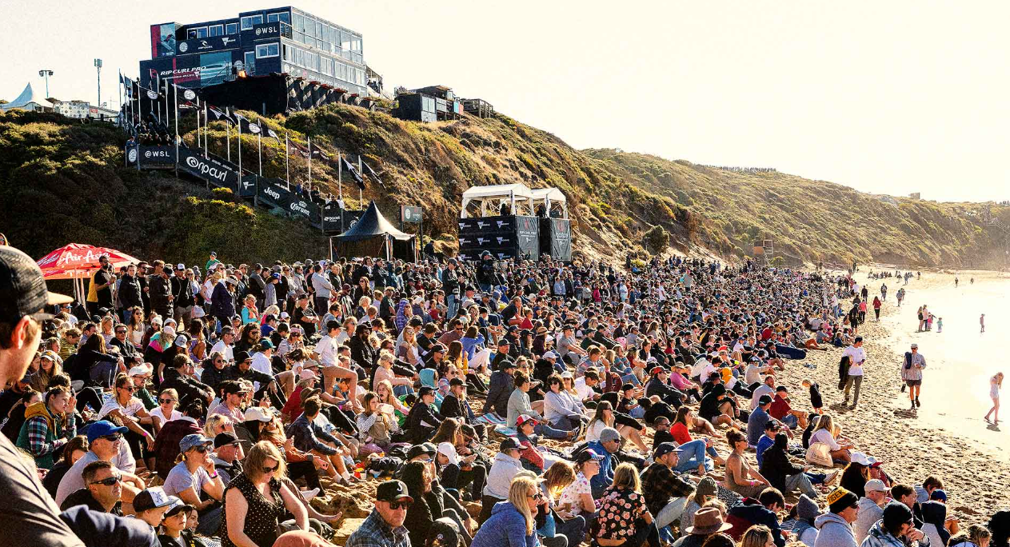
Especially over the Easter and on the weekends. It will be less busy during the week.

There will be quiet and loud zones and I can choose where to go by looking at the sensory map.

If I need a break from the noise and the crowd, there is a quieter space on the sand where I can go. It is away from the large crowd but I can still watch the surfing competition that’s happening in the ocean.

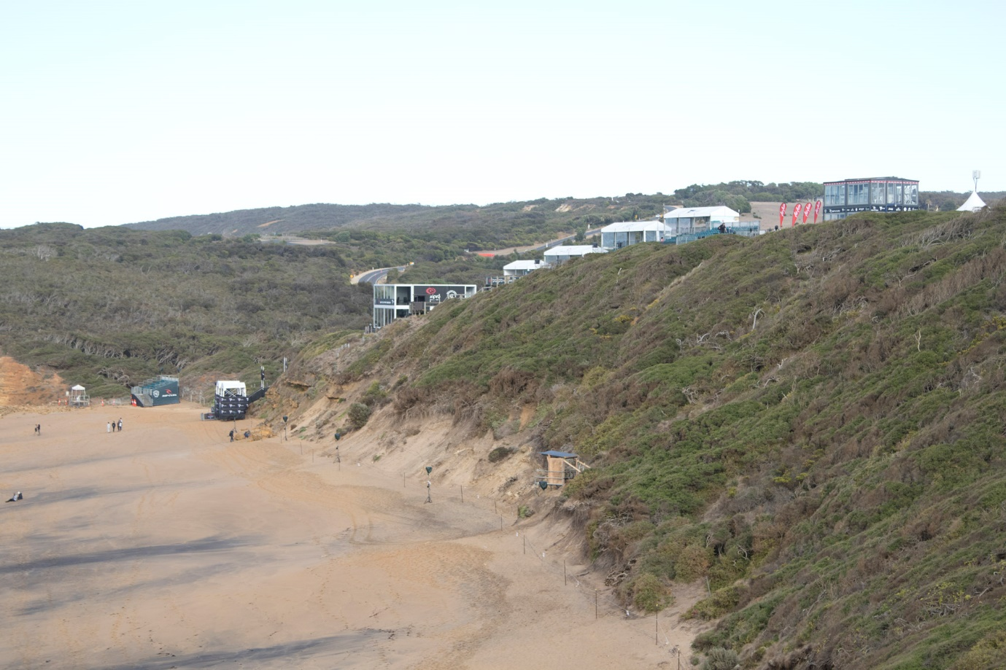
If it gets too loud I can also use my own ear defenders or hire noise cancelling headphones from the Rip Curl Pro First Aid station. I just need to leave an I.D card with a photo.
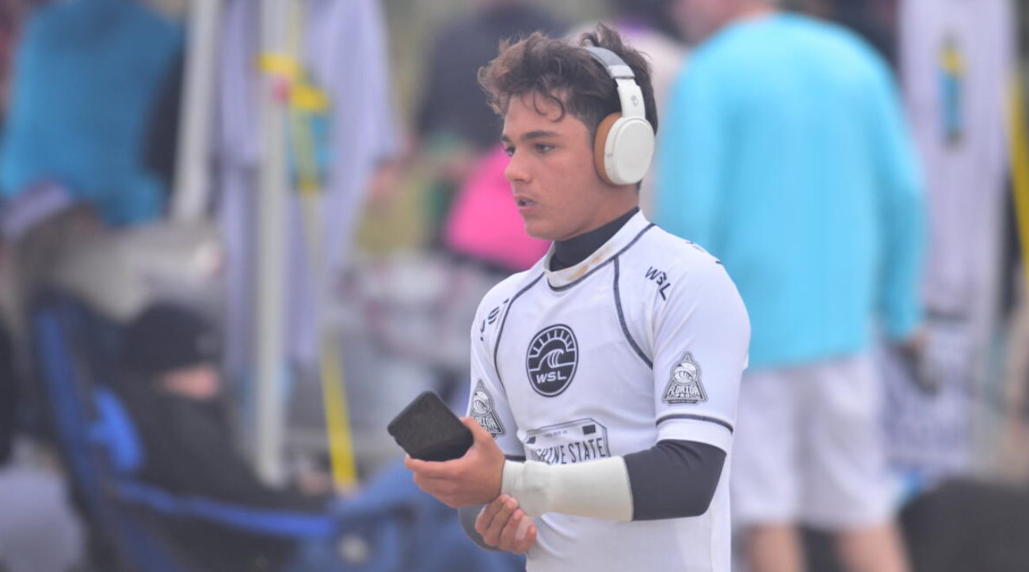

I can leave and come back to the event at any time during the day if I need.
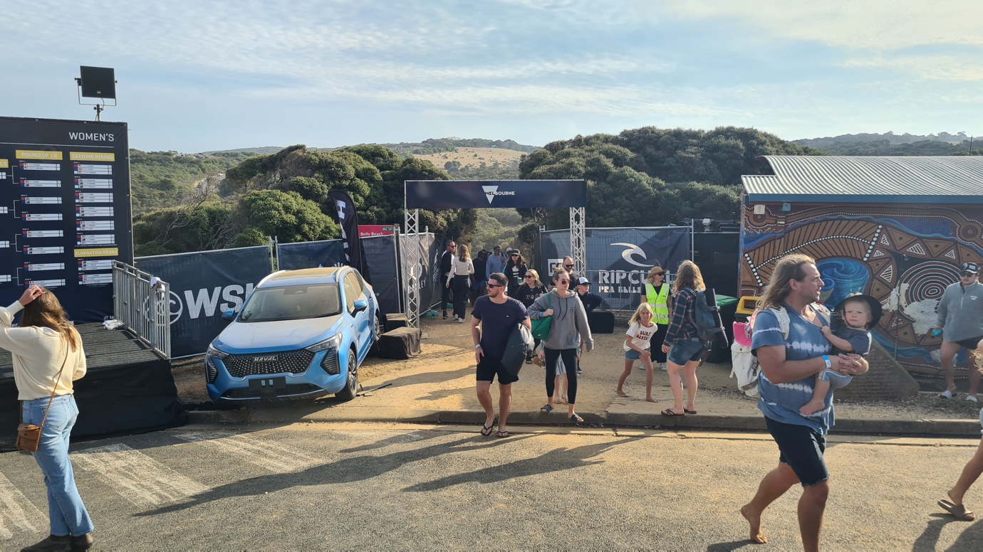
If I get hungry and I have money with me, there are food stalls where I can buy some food to eat.
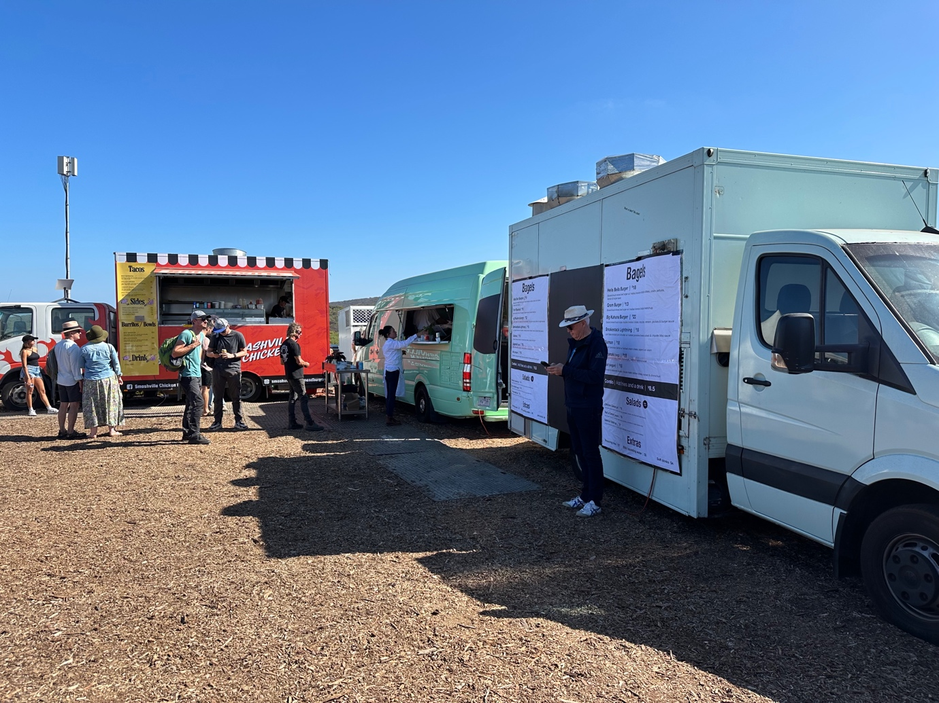

If I need help, Rip Curl Pro security staff are ready to help me as well as the first aiders in the First Aid tent, they will be wearing light blue polo shirts or jumpers.
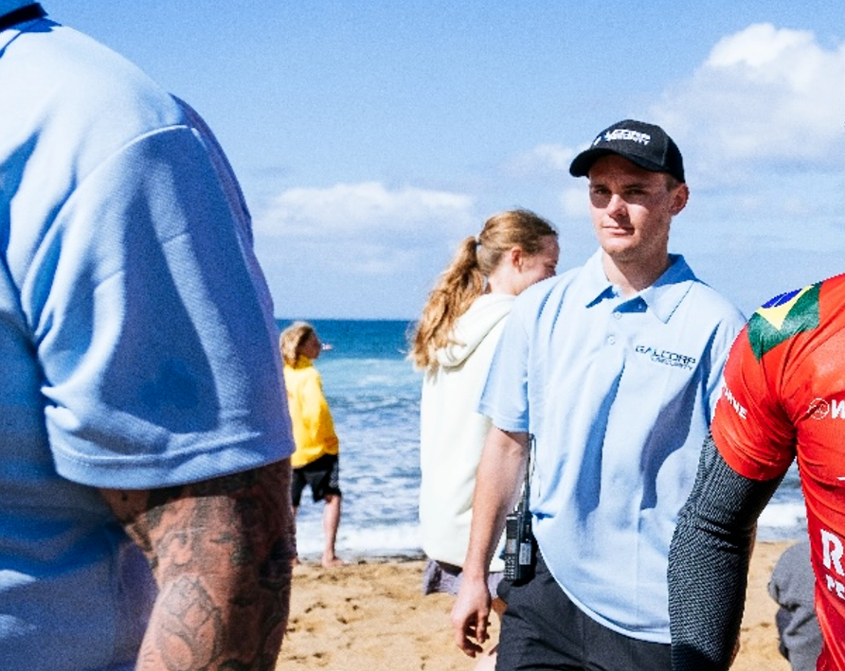
At the end of the event, it will be time to leave and go home.
Going to the Rip Curl Pro will be super awesome!
